**MARKET OF SOFTWARE APPLICATIONS**

If we think that free apps are not as profitable as much as the paid apps ones, then we couldn’t be more wrong. The fact that 98% revenue of worldwide revenue comes from the free apps, according to Google play.

* The leader in this category is Apple’s iOS platform with over 25% of its developers earning over $5000 per month.
* Android is also a well regarded platform. 16% of its app developers earn over $5000 per month in revenue.

This is all because of different opportunities of free app monetization.

**App Monetization options**

Hybrid Monetization models, such as in app ads and in app purchases are quickly gaining popularity in the business world, we can conclude the monetization techniques as follows:

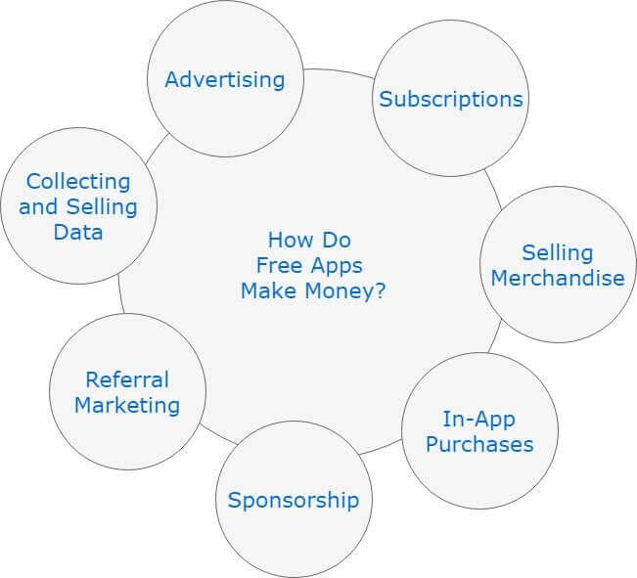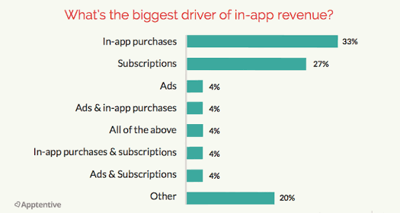

**Fig: Different ways of App Monetization**

**Advertisements are the most popular way of earn money from which are of following types:**

* Banner ads
* Native ads
* Video ads
* Industrial ads
* Inertial ads
* Incentivized ads

Besides this some other ways are also available to earn from apps.

* In app purchases
* Referral/ Niche-Promotion Marketing
* Subscription
* Affiliate Marketing

***Expectedly, the mobile developer has boomed, and the no. of mobile apps in the market has hit a new heights and the market will grow like this at a CAGR growth of 19.2% till 2023.***

So, we can understand there is a great business opportunity in the field of free mobile apps.